
NEWS PHONE APPLICATION
User’s Manual

COP 4331 Section 1
Fall 2010

GROUP 8
Karl Banks
Aaron Birencwaig
Andrew Harmic
Jason Heintz
Stephen Rodriguez
Tyler Zaino

UNIVERSITY OF CENTRAL FLORIDA
USER’S MANUAL
Modification history:
Version | Date | Who | Comment
v1.0 | 11/26/10 | Karl Banks | Initial User’s Manual
v2.0 | 11/27/10 | Tyler Zaino | User’s Manual complete
1 System Description
The CNN NewsApp is a mobile application that delivers news directly to any Android device running the application. It retrieves news from five different sections, World, US, Money, Entertainment and Sports. The application allows the user to first pick which section of news they would like to read, and from there they are presented with the article title along with a short description. The user then has an option to either open the article in the application, or they have the option to open it within the Android device’s built-in browser. Also the application allows the user to search through older articles by using the “See More” option located at the end of the article list.
2 System Requirements
- Android Phone
- Android OS 1.5 or higher
- Internet Connection (Wi-Fi or 3G)
3 User’s Manual
 | 1. Open the application by clicking the NewsApp icon.
 | 2. Once the application is fully loaded, the user is presented with the main screen. Here the user can select which subject of news they would like to read.
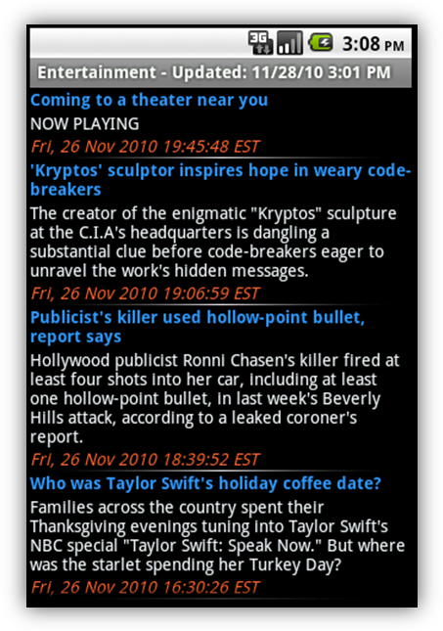 | 3a. By clicking the subject, the user is then presented with a list of articles grabbed from the CNN website.
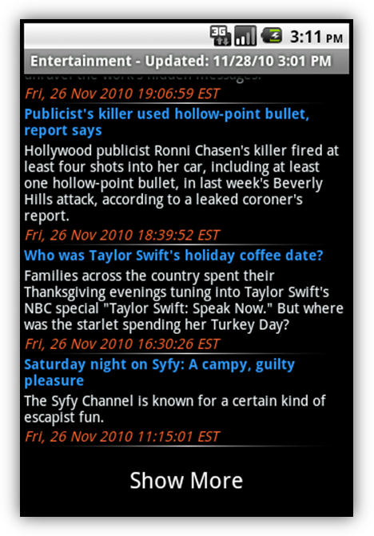 | 3b. If the user is not satisfied with the articles presented, they are able to see more articles by scrolling to the bottom of the article list and clicking “Show More”
 | 4. Once the user finds an article they are interested in, they are able to simply click the article and load it into the application.
5. The user is also presented with more options by long-clicking the article in the article list.

- Open article – Simply opens the article within the application.
- Open article in Browser – Opens the article within the Android devices built-in browser.
- Mark as Read/Unread – Marks or unmarks the article in the article list to show if the article has been read or not.

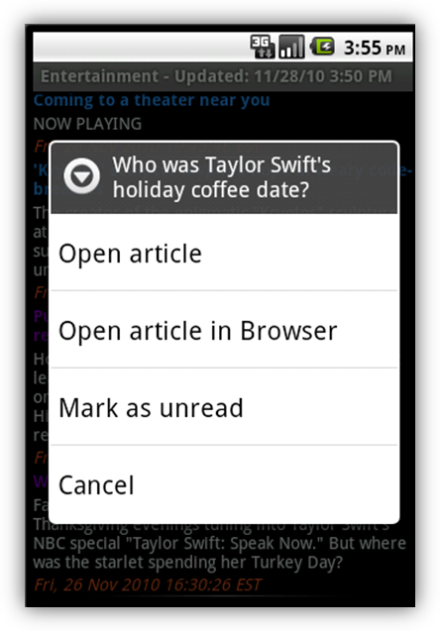 | 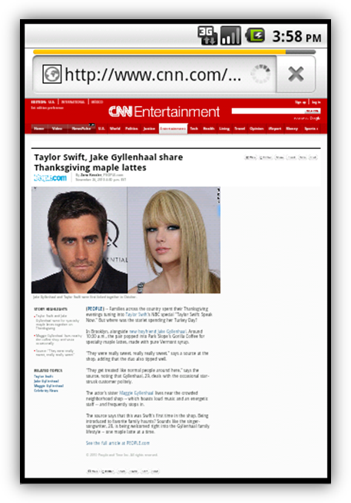
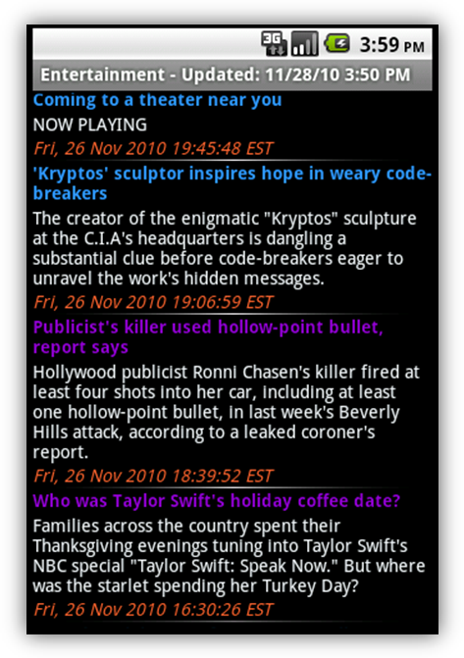 | 6. At any time, if the user wants to jump to another genre of news, they can simply click the Menu button on the Android device.

